Updated 1/7/24

Red - MS/HS Snow & Emergency Route

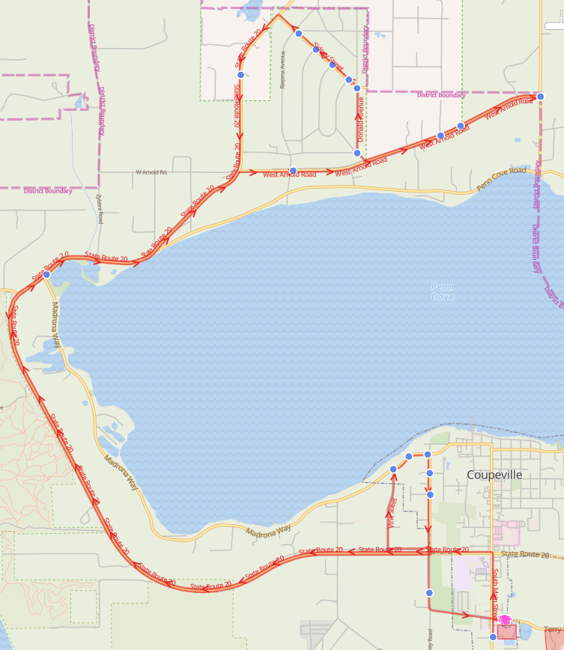

Red - MS/HS Snow & Emergency Route

Reg Start 2- Hr. Delay
7:01 AM |  | 9:01 AM | Hwy 20 & Madrona Way (Transit Stop)
7:04 AM |  | 9:04 AM | Arnold Rd & Riepma Ave (Transit Stop)
7:10 AM |  | 9:10 AM | Monroe Landing Rd & Arnold Rd
7:13 AM |  | 9:13 AM | 1362 Arnold Rd
7:13 AM |  | 9:13 AM | Arnold Rd & Tanner Rd
7:15 AM |  | 9:15 AM | Sharon St & Donald Ave
7:18 AM |  | 9:18 AM | Donald Ave & Sidney St
7:18 AM |  | 9:18 AM | Sidney St & Carl Ave
7:19 AM |  | 9:19 AM | Sidney St & Diane Ave
7:19 AM |  | 9:19 AM | Sidney St & Shawn Ave
7:22 AM |  | 9:22 AM | 1126 Sidney St
7:26 AM |  | 9:26 AM | 27263 Hwy 20
7:36 AM |  | 9:36 AM | Madrona Way & Vine St
7:36 AM |  | 9:36 AM | 701 Madrona Way
7:37 AM |  | 9:37 AM | Madrona Way & Broadway St
7:37 AM |  | 9:37 AM | Broadway St & 7th St
7:38 AM |  | 9:38 AM | Broadway St & 4th St
7:39 AM |  | 9:39 AM | 26 Ebey Rd

Red - Elementary Snow & Emergency Route

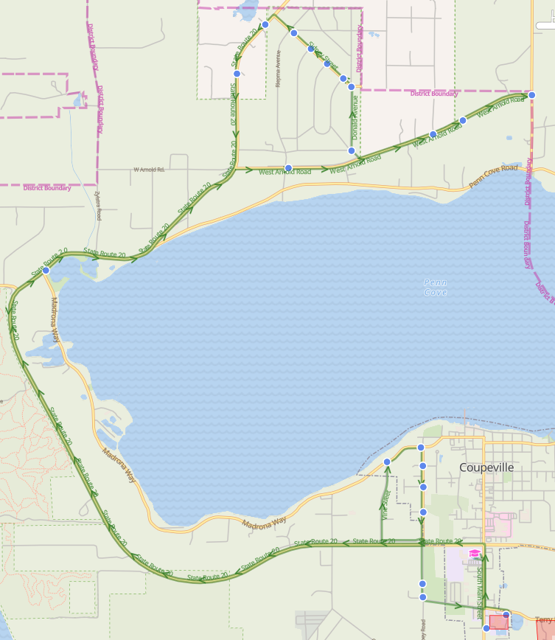

Blue- Elementary Snow & Emergency Route

Reg Start 2- Hr. Delay
8:01 AM | 10:01 AM | Hwy 20 & Madrona Way (Transit Stop)
8:04 AM | 10:04 AM | Arnold Rd & Riepma Ave (Transit Stop)
8:07 AM | 10:07 AM | 1407 Arnold Rd
8:08 AM | 10:08 AM | 1345 Arnold Rd
8:09 AM | 10:09 AM | Monroe Landing Rd & Arnold Rd
8:12 AM | 10:12 AM | Sharon St & Donald Ave
8:15 AM | 10:15 AM | Donald Ave & Sidney St
8:16 AM | 10:16 AM | Sidney St & Carl Ave
8:16 AM | 10:16 AM | Sidney St & Diane Ave
8:17 AM | 10:17 AM | Sidney St & Shawn Ave
8:20 AM | 10:20 AM | 1126 Sidney St
8:25 AM | 10:25 AM | 27569 Hwy 20
8:26 AM | 10:26 AM | 27263 Hwy 20
8:36 AM | 10:36 AM | Madrona Way & Vine St
8:36 AM | 10:36 AM | Madrona Way & Broadway St
8:37 AM | 10:37 AM | Broadway St & 7th St
8:38 AM | 10:38 AM | Broadway St & 4th St
8:38 AM | 10:38 AM | Broadway St & Oakmont St
8:39 AM | 10:39 AM | 26 Ebey Rd
8:40 AM | 10:40 AM | 46 Ebey Rd

